REQUIREMENT ANALYSIS PHASE
Date | 31 January 2025
Team ID | LTVIP2026TMIDS73798
Project Name | Online Payments Fraud Detection Using Machine Learning

2.1 Project Architecture (Data Flow Diagram)
The system follows a structured machine learning pipeline integrated with a web interface.
🔹 Overall System Architecture
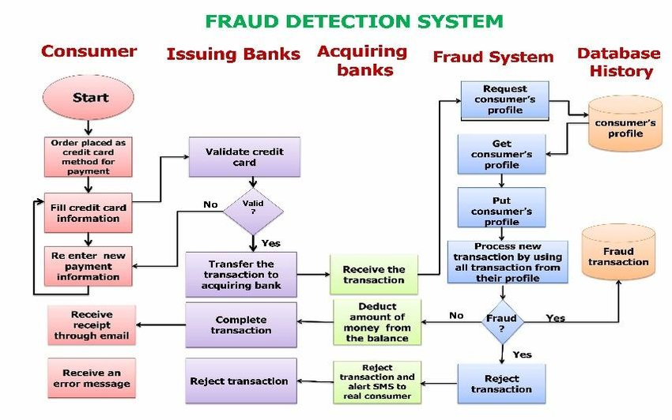
Architecture Explanation
The architecture consists of the following components:
- User Interface (Streamlit Web App)
  - Accepts transaction inputs
  - Displays prediction results
- Input Validation Layer
  - Ensures all fields are filled
  - Converts input into numeric format
- Feature Engineering Layer
  - Encodes transaction type
  - Aligns input features with trained model
- Machine Learning Model
  - Random Forest Classifier
  - Predicts fraud probability
- Output Layer
  - Displays:
    - Fraud / Legitimate
    - Fraud Probability
    - Risk Level (Low / Medium / High)

2.2 Data Flow Diagram
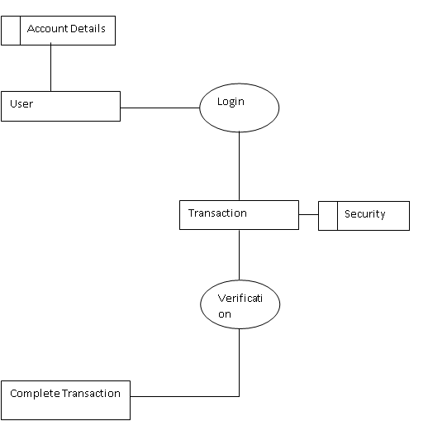

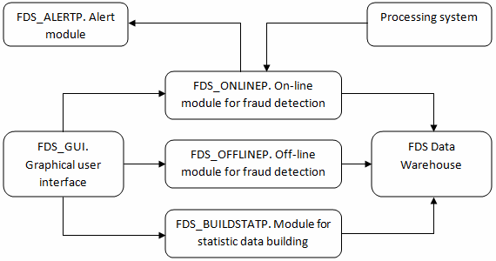

DFD Explanation
External Entity:
- User
Process:
- Fraud Detection System
Data Flow:
- User → Transaction Details → System
- System → Fraud Prediction → User

2.3 Solution Requirements (Prerequisites)
2.3.1 Hardware Requirements
- Minimum 4GB RAM
- Dual-core processor or above
- 10GB free storage

2.3.2 Software Requirements
- Python 3.x
- Jupyter Notebook
- VS Code or any IDE
- Web Browser

2.3.3 Python Libraries Required
- pandas
- numpy
- scikit-learn
- joblib
- streamlit
Installation command:
pip install pandas numpy scikit-learn joblib streamlit

2.4 Technology Stack (Project Flow)
🔹 Technology Stack Overview
Layer | Technology Used
Programming Language | Python
Data Processing | Pandas, NumPy
Machine Learning | Scikit-learn (Random Forest)
Model Storage | Joblib
Frontend Interface | Streamlit
Development Tool | Jupyter Notebook, VS Code

🔹 Project Flow Diagram
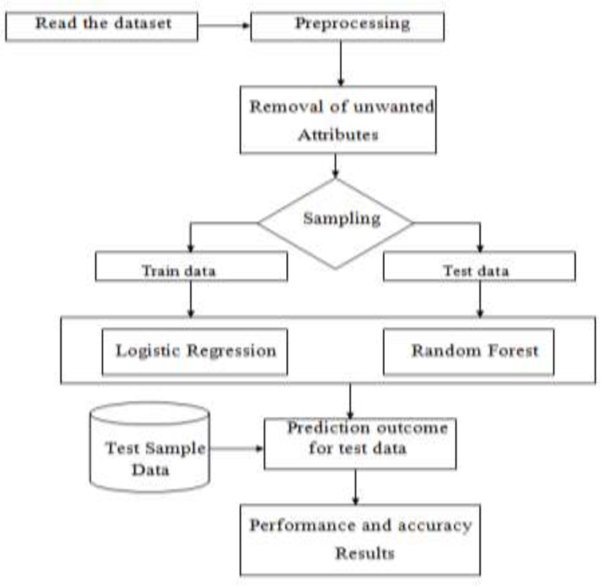

Project Flow Steps
- Dataset Collection
- Data Preprocessing
- Feature Engineering
- Model Training
- Model Evaluation
- Model Saving
- Web Application Development
- User Input → Prediction → Risk Classification

2.5 Functional Requirements
- System must accept transaction inputs
- System must predict fraud probability
- System must classify risk level
- System must display result clearly

2.6 Non-Functional Requirements
- High accuracy
- Fast prediction response
- User-friendly interface
- Reliable model loading

